**Development and Implementation of an E-Commerce for Tajikistan, specifically for Pamir, Badakhshan**



By

Markhabo Rakhmatshoeva

In partial fulfillment of the requirement for the degree Bachelor of Science in Computer Science

Department of Computer Science, School of Arts & Science University of Central Asia, Naryn Campus, Kyrgyz Republic

(2024)

#### DECLARATION BY AUTHOR

I certify that this work has not been accepted in substance for any degree and is not concurrently being submitted for any degree other than that of Bachelor of Science in Computer Science being studied at the Department of Computer Science, School of Arts & Science, University of Central Asia, Kyrgyz Republic. I further declare that I have not plagiarized anyone's work and that this work is the result of my own research and results, unless otherwise indicated by references.

Markhabo Rakhmatshoeva

­­­­­­­

#### DECLARATION BY SUPERVISOR

I, the undersigned hereby certify that I have read this project report and finally approve it with recommendation that this report may be submitted by the authors above to the final year project evaluation committee for final evaluation and presentation, in partial fulfillment of the requirements for the degree of Bachelor of Science in Computer Science at the Department of Computer Science, School of Arts & Sciences, University of Central Asia, Kyrgyz Republic.

Dr. Ayman Aljarbouh

## ACKNOWLEDGEMENT

Working on my Final Year Project was a tremendously rewarding experience, albeit challenging. I chose a substantial project despite being warned about the significant efforts required, because I envisioned integrating this e-commerce platform into my future business endeavors. Throughout the project, I encountered numerous challenges, such as a lack of knowledge and experience. However, I am pleased with the progress I made and, ultimately, with the successful completion of the project. Of course, I didn’t achieve this alone. Many people believed in me and supported me, assisting in bringing this project to life.

First and foremost, I would like to express my gratitude to my supervisor, Dr. Ayman Aljarbouh, Chair of the Department of Computer Science, for his endless support. He helped me stay on track with my project and was always there to offer support. His assistance was crucial in overcoming administrative hurdles. Thank you so much, Dr. Ayman, for your support; it is greatly appreciated.

Additionally, I am grateful to my senior, who provided tremendous mental support and motivation to take on and successfully complete this challenge.

Thank you so much!

## ABSTRACT

AliCart is a new e-commerce platform designed to improve the shopping experience in Badakhshan, Tajikistan, especially for residents of remote areas like Pamir. This initiative aims to enhance quality of life by making a diverse range of products easily accessible from home or work, reducing the need for lengthy trips to distant markets.

Badakhshan faces challenges like limited access to diverse and affordable products. For instance, essential items and luxury goods are hard to come by and are often expensive, with significant shopping centers located many hours away. AliCart offers a convenient and secure way to shop online for everything from daily necessities to specialized items. The platform also supports local artisans and farmers by allowing them to sell their products directly to consumers, thus helping to boost their incomes.

Unlike existing e-commerce platforms that either overlook or inadequately serve the area, AliCart builds on the community’s trust in the founder’s family-owned stores in Khorog. To promote the platform, AliCart will include a 5% discount on all items and free delivery for orders over 1000 somoni within Khorog. Together with 24/7 customer support and a physical store for immediate help, these efforts aim to ease the community into online shopping.

By introducing AliCart, we hope to not only change shopping habits in Badakhshan but also empower local vendors by giving them a wider market to sell their goods. This project is set to play a vital role in advancing digital commerce in one of Tajikistan's most isolated regions.

**Keywords:** E-Commerce, Online shopping, Food and clothing, Technology, Fashion Industry, Branded clothes, Trust and reliability, Safe delivery, Accessibility, Affordability, Variety of item.

**TABLE OF CONTENTS**

ACKNOWLEDGEMENT 3

ABSTRACT 4

CHAPTER I: INTRODUCTION 9

**1.1** Background 9

**1.2** Problem Statement 9

**1.3** Scope of the Project 10

**1.4** Expected Outcomes 11

**2.1** Introduction to E-commerce Landscape in Central Asia 13

**2.2** Understanding Consumer Behavior in Online Clothing Purchases 13

**2.3** Exploration of Market Readiness and Cultural Aspects 14

**2.4** Challenges in E-commerce Adoption and Economic Landscape 15

**2.5** Importance of Customer Engagement and Financial Integration 15

**2.6** Addressing the Digital Knowledge Gap 15

**2.7** Conclusion: Bridging Gaps and Making Contributions 15

CHAPTER III: Technical Specification 19

**3.1** Overview 19

**3.2** System Architecture and Technologies 19

**3.3** Functional and Non-Functional Requirements 20

**3.4** Hardware and Software Requirements 25

CHAPTER IV: METHODOLOGY 26

**4.1** Introduction 26

**4.2** Research Design 26

**4.3** Data Collection 27

**4.4** Data Analyses 28

**4.5** Validity and Reliability 28

**4.6** Limitations 29

CHAPTER V: SYSTEM DESIGN AND USER GUIDE 33

**5.1** **System Design** 33

**5.2** **User Guide** 36

**5.3** **Django Models and Database Design** 37

**5.4** **Django Models and Database Design** 38

CHAPTER VI: RESULTS AND DISCUSSION 39

**6.1** Results of user testing and Comments 39

**6.2** Testing Outcomes and Steps Taken 39

**6.3** Contributions and Achievements of the E-Commerce AliCart 39

CHAPTER VII: CONCLUSION AND FUTURE WORK 40

**7.1** Limitation of the present study and the suggestions for further investigation or enhancement of future research 40

**7.2** Future Recommendations 40

REFERENCES 41

Table of figures

List of tables

## CHAPTER I: INTRODUCTION

As digital technology reshapes industries globally, ecommerce has emerged as a pivotal element in modern economic development. However, its impact varies across regions, with Central Asia, particularly Tajikistan Pamir, lagging in the adoption and integration of online shopping platforms.

### Background

The inception of ecommerce was marked by the emergence of platforms like Amazon and eBay in the 1990s, revolutionizing the retail landscape by enabling consumers to access an expansive range of products from their homes and allowing sellers to reach global audiences. This digital transformation was supported by advances in mobile technology, secure online transactions, and efficient logistics. Despite the global proliferation of ecommerce, its penetration in Tajikistan has been slow, hindered by infrastructural deficiencies, logistical challenges, and a general reluctance to adopt new shopping modalities.

### Problem Statement

In Tajikistan, traditional e-commerce platforms are underutilized, and most people rely on social media and informal online markets for their purchases. This approach presents several challenges, particularly for those living in remote areas like Badakhshan. Residents in these areas often struggle to access basic goods and services, and the lack of established online platforms means they frequently have to undertake long, costly trips to urban centers to buy essentials. According to local sources, there is just one e-commerce website in the region, but it is not being developed further because the owner believes that people are reluctant to use it.

Additionally, local vendors and artisans find themselves economically isolated because they don't have a platform that allows them to reach a broader market. This limitation not only stifles economic growth but also restricts their potential customer base, making it difficult for them to expand their businesses.

In Tajikistan, the high costs of importing goods, along with the logistical complications linked to international e-commerce platforms, often discourage their use among local consumers. Popular e-commerce platforms like Wildberries and Amazon, which are trusted by my community, unfortunately do not offer delivery to Tajikistan, leaving us without options. This lack of access forces residents to rely on limited local resources and informal selling platforms, which do not adequately serve their needs. These barriers present significant challenges in accessing a diverse range of products. Such circumstances underscore the critical need for a more accessible and efficient online shopping solution tailored to address the unique economic and logistical challenges faced by Tajik consumers.

### Scope of the Project

The scope of this project is to launch AliCart, an innovative e-commerce platform tailored specifically for the residents of Badakhshan, Tajikistan. Our goal is to transform the regional e-commerce landscape by providing a reliable and user-friendly online marketplace that caters to the needs of local consumers.

Firstly, we will develop and deploy AliCart, ensuring the platform is intuitive and mobile-friendly to accommodate the diverse range of devices used by consumers in Badakhshan. This development will facilitate easier browsing, selection, and purchasing of a broad spectrum of products.

Secondly, the platform will diversify the available product offerings, including daily necessities and specialty items such as branded clothing and technology, which are scarce in local markets. This approach aims to minimize the residents' need to travel to distant urban centers for shopping.

In addition, AliCart will actively support local vendors, artisans, and small businesses by enabling them to sell their products online. This initiative will include creating vendor profiles, setting up product listings, and providing support for logistics and delivery.

To address the high import costs and logistical challenges, the project will establish partnerships with local and regional couriers to ensure reliable delivery services. We also plan to set up local collection centers to facilitate distribution and make receiving products easier for customers.

Customer support will be a cornerstone of the platform, with a 24/7 support center to assist users with any issues they encounter. Support will be accessible via phone, message, and social media, ensuring that help is readily available.

Finally, we are committed to the sustainability and growth of AliCart. Future plans include expanding the product range, enhancing platform features based on user feedback, and exploring opportunities to expand into additional markets within Tajikistan and potentially into neighboring regions.

Through these focused efforts, the project aims not just to meet the immediate shopping needs of the local population but also to contribute to the long-term economic growth and development of the community.

### Expected Outcomes

For this ecommerce platform project, several positive outcomes are anticipated, assuming effective implementation and management.

Firstly, enhanced accessibility and convenience. Customers in Badakhshan will have easier access to a broader range of products, from basic necessities to luxury items, all available online. This convenience eliminates the need for long, costly trips to distant markets, saving time and reducing travel related stress.

Secondly, economic empowerment of local vendors. By providing a platform for local artisans and vendors, especially those without the means to establish their own online presence, AliCart can significantly boost local entrepreneurship. This enables them to reach a wider customer base, potentially increasing their sales and income.

Thirdly, improved market competition. The introduction of AliCart is likely to stimulate competitive pricing and variety, benefiting consumers. It can force existing businesses to innovate and improve their offerings, which elevates the overall market quality.

Besides, it can also create jobs. It’s operation will require a range of new roles, from logistics and customer support to technical development and management. This job creation can be a significant boon to the local economy, providing employment opportunities and developing local talent.

Furthermore, it contributes to strengthening of local economy. Increased sales, business opportunities, and job creation contribute to strengthening the local economy. Moreover, keeping the spending within the community enhances economic resilience.

With a commitment to quality, customer service, and reliable delivery, consumer satisfaction and trust in online shopping within the community are expected to rise. This shift can lead to increased adoption of ecommerce solutions locally.

By centralizing deliveries and potentially optimizing logistics, AliCart can contribute to a reduction in the carbon footprint associated with individual travel for shopping. Additionally, offering locally produced goods reduces the environmental costs of importing products from distant locations.

AliCart provides a unique opportunity to promote local crafts and products to a broader audience, potentially reaching beyond regional boundaries. This not only helps preserve cultural heritage but also educates others about the region's crafts.

The digital nature of the platform allows for the collection of detailed data on consumer behavior, preferences, and trends. These insights can be leveraged to improve product offerings, marketing strategies, and customer experiences.

If successful locally, the business model of AliCart could be replicated in other similar regions, both within Tajikistan and in other countries, scaling the impact and profitability of the venture.

These outcomes encapsulate the transformative potential of the AliCart project, not just in terms of commercial success but also in fostering a more connected, economically vibrant, and technologically advanced community.

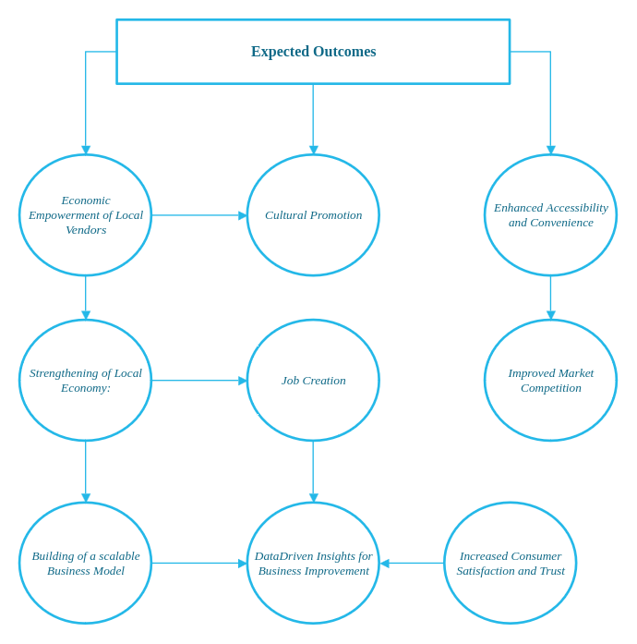

CHAPTER II: LITERATURE REVIEW

### Introduction to E-commerce Landscape in Central Asia

Electronic commerce (e-commerce) has transformed consumer behavior globally, providing unparalleled convenience in online shopping (Amin, Kansana, & Majid, 2016). Despite its widespread adoption, Central Asia, particularly Tajikistan, remains relatively unexplored in this context. Major players such as Alibaba and Tencent have shown interest in this market gap (Xiao et al., 2018), emphasizing the importance of user interface, customer interaction, and integration with local financial systems (Kalaskar et al., 2023; Yaqoob et al., 2019). These insights serve as the basis for our Final Year Project (FYP), which seeks to address the research question: "How can a tailored e-commerce platform meet the specific needs of the Central Asian market, starting with Tajikistan, Badakhshan?" Our methodology includes market surveys, interface design, testing, and partnerships with local financial institutions. Through this project, we aim to contribute to the field by offering a localized e-commerce solution.

### Understanding Consumer Behavior in Online Clothing Purchases

The evolving landscape of electronic commerce (e-commerce) has revolutionized consumer behavior globally, offering unparalleled convenience and accessibility to products and services (Amin, Kansana, & Majid, 2016). However, the exploration of e-commerce dynamics within Central Asia, particularly Tajikistan, remains relatively underexplored. As major players like Alibaba and Tencent recognize the market potential in this region (Xiao et al., 2018), it becomes imperative to delve into the factors influencing consumer behavior in online shopping, especially regarding clothing, in locales such as Manado (Ida Ayu Debora, 2016).

Research reveals that factors such as the availability of products, refund policies, and perceived ease of use significantly influence consumer decisions in online clothing purchases (Ida Ayu Debora, 2016). These findings resonate with the broader global trends of consumers' evolving preferences in the digital age, where convenience, variety, and seamless transactions play pivotal roles in shaping buying behavior (Reena et al., 2020).

Moreover, the intersection of fashion and technology has led to the emergence of smart clothing and wearables, representing a fusion of convenience, style, and innovation (Jamal & Kapoor, 2022). This paradigm shift underscores the importance of integrating technological advancements into the fashion retail sector to cater to the demands of tech-savvy consumers.

In the context of Tajikistan, the adoption of digital technologies among the younger demographic signifies a shift towards embracing modernity and connectivity (Gairatovich, 2018). However, challenges persist, including limited internet access and digital literacy, which hinder widespread digitalization efforts (Tulyev, 2022). Nonetheless, there is a growing recognition of the potential of digital innovations in driving economic growth and enhancing consumer experiences in Tajikistan (Mukimova & Berdieva, 2022).

Furthermore, the role of information technologies in Tajikistan's digital economy cannot be overstated (Temurbekova & Sulaimonov, 2022). From enhancing business operations to facilitating access to global markets, technology serves as a catalyst for socio-economic development in the region.

Additionally, the digitalization of Tajikistan's banking sector reflects broader trends in the country's economic landscape, with a gradual transition towards digital banking services (Akhrorova, 2022). However, infrastructural limitations and low digital literacy levels pose significant challenges to the widespread adoption of digital technologies in Tajikistan.

In summary, the literature underscores the multifaceted nature of digitalization and its implications for consumer behavior, economic development, and technological innovation in Tajikistan. By leveraging insights from existing research, our project aims to bridge existing gaps in the e-commerce landscape of Central Asia, thereby contributing to the region's digital and economic advancement.

### Exploration of Market Readiness and Cultural Aspects

Xiao et al. (2018) explore the opportunities for Chinese online retail businesses to expand into Central Asia, focusing on market readiness, local cultural aspects, and strategic geopolitics such as the Belt and Road Initiative. However, these discussions often generalize about Central Asia, overlooking unique situations in individual countries like Tajikistan. Our project aims to rectify this oversight by developing a specialized approach for the Tajik market, initially targeting strong consumer interest in name-brand apparel.

### Challenges in E-commerce Adoption and Economic Landscape

Furthermore, the economic landscape of Central Asia presents distinct challenges for e-commerce adoption. Elevated import duties and shipping costs can significantly inflate the final price of goods, particularly in Tajikistan where access to high-quality, branded clothing is limited and expensive. Recent advancements in digital governance in Tajikistan (Қурбонов & Исматуллои, 2020) indicate a growing market for e-commerce ventures, providing a favorable environment for our project. Our initiative also seeks to establish partnerships with local suppliers to offer a diverse range of products to our customers.

### Importance of Customer Engagement and Financial Integration

In line with research by Kalaskar et al. (2023), our FYP emphasizes the significance of customer engagement and appealing aesthetics in shaping the success of online retail platforms. We aspire to construct an intuitive and user-friendly interface specifically designed for Central Asian, and particularly Tajik, consumers. Additionally, Yaqoob et al. (2019) stress the critical role of partnerships with domestic financial infrastructures for secure financial transactions. Expanding on this understanding, our initiative intends to incorporate prevalent payment solutions in Tajikistan, such as the Dushanbe City card, to offer a seamless shopping experience.

### Addressing the Digital Knowledge Gap

Another significant barrier to e-commerce adoption in Central Asia is the digital knowledge gap. Investigations by Chib et al. (2018) suggest that educational materials and approachable platforms are crucial for closing this gap. Our platform plans to feature educational content to assist newcomers in understanding the nuances of the e-commerce environment, thereby promoting digital literacy and enhancing user experience.

### Conclusion: Bridging Gaps and Making Contributions

In summary, our project aims to fill existing research gaps by adopting a localized approach to e-commerce in Central Asia, with a focus on addressing the specific needs of the Tajik market. By challenging prevailing China-centric models and catalyzing digital and economic development in Tajikistan, we seek to make significant contributions to both the e-commerce landscape and Tajikistan's broader developmental goals. Through this integrated review of existing literature, we are well-positioned to develop a robust and impactful e-commerce platform tailored to the needs of Central Asian consumers.

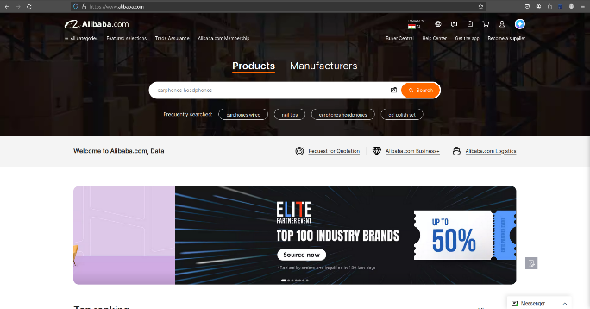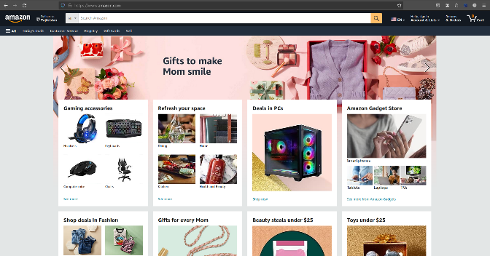

Business Benefits:

AliCart, an ecommerce platform tailored for the unique market of Tajikistan, specifically in Pamir, Badakhshan, offers numerous business benefits. These advantages not only contribute to the platform's potential success but also positively impact the local economy, vendors, and consumers. Here are the key business benefits of launching and operating AliCart:

First of all, it provides local vendors and artisans an opportunity to expand their market reach beyond traditional boundaries. By connecting these sellers to a broader audience, it facilitates access to a wider customer base, potentially increasing sales and revenue.

By providing an online marketplace, the platform enables consumers, especially those in remote or underserved areas, to access a variety of products that might not be otherwise available locally. This convenience can lead to an increase in customer satisfaction and loyalty, as well as higher overall consumption.

The website offers a more streamlined and userfriendly shopping experience compared to traditional or informal market setups. Features like advanced search options, customer reviews, and secure checkout processes significantly enhance the way customers shop, making it easier and safer.

For vendors, operating online can reduce the overhead costs associated with physical stores, such as rent, utilities, and inperson staff. This shift lowers the barrier to entry for new vendors and increases profitability for existing businesses, providing an excellent opportunity to initiate a business and make it wellknown.

The digital nature of an ecommerce platform like AliCart provides scalability options that physical markets cannot match. As the business grows, AliCart can expand its offerings and services without the need for proportionally large investments in physical infrastructure.

By promoting local businesses and products, AliCart contributes to the economic vitality of the region. This support can lead to job creation in areas like logistics, customer service, and digital marketing, further stimulating local economic development.

AliCart can introduce innovative selling and marketing tools such as flash sales, loyalty programs, and personalized marketing, which can be powerful methods to increase sales and customer retention.

With more efficient logistics and a centralized delivery system, AliCart can help reduce the carbon footprint associated with traditional shopping methods, which often involve multiple individual trips to various stores.

By consistently providing reliable services and quality products, along with excellent customer support, AliCart can build a strong reputation and trust among its user base. This trust translates into brand loyalty and can significantly contribute to longterm business success.

The digital platform allows AliCart to quickly adapt to market changes or consumer needs, whether this involves adding new product categories, adjusting pricing, or enhancing delivery services.

Offering free delivery for orders that exceed 1000 somoni will encourage customers to place larger orders and become repeat customers.

As the platform grows, it will create new jobs in various sectors, including tech, logistics, and customer service. This expansion is seen as an excellent opportunity for community building and economic development.

In conclusion, AliCart is positioned not only to transform the shopping landscape in Tajikistan, initially in Pamir, Badakhshan but also to deliver substantial business benefits, driving forward the modernization and globalization of the local market. This venture promises to create a sustainable business model that benefits all stakeholders involved.

### CHAPTER III: Technical Specification

### Overview

The technology, programming languages, and libraries used to create e-commerce are described in detail in this chapter. The functional and non-functional requirements of the project are also described to give a thorough understanding of the objectives of the project.

### System Architecture and Technologies

Alicart is an e-commerce platform tailored to the rural community of Badakhshan, Tajikistan, aiming to simplify life and contribute to the local and national economy. The Python programming language and the Django web framework were chosen for this project's development because of their relative benefits and widespread use in the development community.

#### Django Web Framework

A popular Model-View-Template framework for web development is called Django. Its scalability, speed, adaptability, and dependability are highly acclaimed. An admin user interface is another element of the framework that makes it easier to add new features to websites. Furthermore, Django provides default protection against a variety of security flaws, including SQL injection, request forgery, cross-site scripting, and clickjacking. Essential frameworks and libraries used for this project include Django REST framework, Channels and Daphne.

#### Python Programming Language

Python is a versatile and flexible programming language that can be used for many different things, including machine learning. Because of its flexibility, it may be used for both website development (with Django) and machine learning. Python has a sizable developer community and an abundance of libraries that can help accomplish the project's objectives. Among the crucial libraries utilized for this project are gunicorn, pandas, and boto3. Making use of these libraries will improve the platform's functionality and trustworthiness.

### Functional and Non-Functional Requirements

To secure the flawless operation of the UCA Face Recognition system and attain its goals, we must scrutinize both functional and non-functional requirements. In the following sections, a deeper exploration of these essentials uncovers the indispensable components for the project's success.

Functional requirements:

*Table 2 Functional Requirements*

|  |  |
| --- | --- |
| **Functional requirement**  **No.** | **Functional Requirement** |
| **FR 1** | Account creation and secure sign-in and sign-up |
| **FR 2** | User – friendly interface for non-tech-savvy customers |
| **FR 3** | Item listening and easy navigation through the platform |
| **FR 4** | Cart management and payment |
| **FR 5** | Delivery options & prompt shipping |
| **FR 6** | Incentives for bulk orders |

#### FR1: Account creation and secure sign-in and sign-up

***Description*:** Users should be able to create accounts and securely sign in.

*Acceptance Criteria:*

* Account creation via email, google account or Facebook , with security measures like single use codes, two factor authentication, or email confirmation for security*.*

#### FR2: User – friendly interface for non-tech-savvy customers

***Description*:** The website should have a user – friendly interface layout that makes it easy for even non-techies to browse the product, view them all, and review the prices and categories for each.

*Acceptance Criteria:*

* Simple navigation and item listings with a standard text size that is marginally larger.

#### FR3: Item listening and easy navigation through the platform.

*Description*: Simple navigation and item listings with a standard text size that is marginally larger.

*Acceptance Criteria:*

* On the main page, display each item's name and photo in a smaller font than the other items.
* Any product that you click on should take you to a page with all of its information, reviews, descriptions, and related products.

#### FR4: Cart management and payment

*Description*: User should manage their shopping cart and proceed to payment

*Acceptance Criteria:*

* Include / exclude items.
* Review cart content.
* Offer multiple payment options including credit cards, and cash on delivery.
* Allow users to select or add new delivery addresses.

#### FR5: Delivery options & prompt shipping

***Description*:** Establish a procedure for user authentication and access authorization to the system and database.

*Acceptance Criteria:*

* Standard or expedited delivery option
* Access to order tracking section on the platform

#### FR6: Incentives for bulk orders

***Description*:** Provide incentives for bulk orders to encourage our customers to continue shopping and remain loyal to us.

*Acceptance Criteria:*

* Free shipping on orders exceeding 1000 Somoni within Khorog
* Free shipping on orders exceeding 2000 Somoni within Suchan

#### FR7: Attendance Tracking System

*Description*: Integrate an attendance tracking system that allows security staff to log and oversee individual’s status on campus and grants administrators or organizers access to attendance records.

*Acceptance Criteria:*

* Record and monitor attendance with minimal errors or inconsistencies.
* Process attendance records efficiently to prevent delays or bottlenecks.
* Handle a substantial volume of attendance records without performance issues.
* Permit administrators or organizers to view and manage students’ campus attendance records.

Non-functional requirements:

*Table 3 Non-function requirements*

|  |  |
| --- | --- |
| **Non-functional requirement**  **No.** | **Non-Functional Requirement Description** |
| **NFR 1** | Speed and Responsiveness |
| **NFR 2** | Privacy |
| **NFR 3** | Consistency & Scalability |
| **NFR 4** | User Friendliness |
| **NFR 5** | Mobile access |
| **NFR 6** | Behavior Metrics |

Acceptance criteria for non-functional requirements

#### NFR1: Speed and Responsiveness

*Description*: Ensure quick performance and adaptability to increased traffic.

*Acceptance Criteria:*

* Web pages load within 2 seconds, architecture withstands 20% traffic increase.

#### NFR2: Privacy

*Description*: Prioritize user privacy and data protection.

*Acceptance Criteria:*

* Use of encryption and defenses against common security threats

#### NFR3: Consistency & Scalability

*Description*: Maintain consistent service availability and build for increasing inventory and user base

*Acceptance Criteria:*

* 99.9% uptime
* Support 10,000 simultaneous users, scalable architecture

#### NFR4: User Friendliness

*Description*: Intuitive user interface

*Acceptance Criteria:*

* Usability score of at least 8/10 based on user feedback.

#### NFR5: Mobile Access

*Description*: Ensure mobile accessibility

*Acceptance Criteria:*

* Responsive website designed to fit well on mobile screens.

#### NFR6: Behavior Metrics

*Description*: Capture and analyze user behavior data.

*Acceptance Criteria:*

* Periodic reports on user behavior, product trends, etc.

### Hardware and Software Requirements

*Table 4 Technical Specification*

|  |  |  |
| --- | --- | --- |
|  | **COMPONENT** | **DESCRIPTION** |
| **HARDWARE** | Server | A dedicated server to host our Django Framework |
| Machine | IIISI |
| OS | Microsoft windows 11 Pro, Version 10.0.22631 |
| CPU | Intel64 Family 6 Model 141 |
| GPU | 16 Core |
| RAM | 16 GB |
| **SOFTWARE** | Django 4.1.7 | Web development framework that is used for building the e-commerce user interface. |
| PostgreSQL | Big-scale database management system for storing and retrieving data. |
| VS Code | Development Environment |
| **PR. LANGUAGE** | Python | A powerful programming language that is used for both machine learning and website development. |
| **LIBRARIES** | Pandas | A library for data manipulation and analysis, providing data structures and operations for manipulating numerical tables and time series. It is not a full framework but is essential for data-intensive applications. |
| Gunicorn | A Python WSGI HTTP Server for UNIX, serving Python applications. It acts as a web server or a gateway interface rather than a framework but is crucial for deploying Python web applications. |
| Django REST framework | A powerful and flexible toolkit for building Web APIs in Django |
|  | Daphne | An ASGI server for Django, handling both HTTP and WebSocket traffic. |
|  |  |  |

## CHAPTER IV: METHODOLOGY

### Introduction

The methodology chapter delineates the procedural framework employed in the development and evaluation of the AliCart ecommerce platform. This chapter serves as a blueprint for conducting the study, outlining the research design, data collection methods, analysis techniques, and evaluation strategies utilized to achieve the project objectives effectively. By elucidating the systematic approach adopted in the research process, this chapter aims to ensure transparency, rigor, and reliability in the study's execution and interpretation.

### Research Design

The research design of the study is characterized by its experimental nature, integrating both quantitative and qualitative research methods to comprehensively address the research objectives. This approach allows for the systematic investigation of the AliCart platform's development, implementation, and impact, facilitating evidence-based decision-making and robust empirical analysis. By combining quantitative data analysis with qualitative insights, the research design enables a holistic understanding of the platform's efficacy, user experience, and market dynamics.

In addition to its experimental nature, the research design incorporates elements of exploratory research, particularly in the qualitative phase, to explore emerging themes, uncover hidden patterns, and generate novel insights into user behavior and preferences. This exploratory component enriches the research process by fostering creativity, flexibility, and openness to unexpected findings, thereby enhancing the depth and richness of the study's conclusions.

Moreover, the research design emphasizes the iterative and adaptive nature of the development process, accommodating feedback from stakeholders, responding to evolving market conditions, and refining research methods and instruments accordingly. This iterative approach fosters continuous improvement and innovation, enabling the AliCart platform to evolve in response to user needs and preferences while maintaining alignment with the project objectives and constraints.

### Data Collection

The data collection process encompasses a multifaceted strategy designed to capture comprehensive insights into various facets of the AliCart platform, including user behavior, system performance, market dynamics, and stakeholder perceptions. As shown Figure XX Quantitative data is collected through a combination of automated system logs, user interactions, and performance metrics generated during the platform's development and testing phases. These data sources provide quantitative indicators of platform usage, engagement, and effectiveness, facilitating rigorous statistical analysis and empirical evaluation.

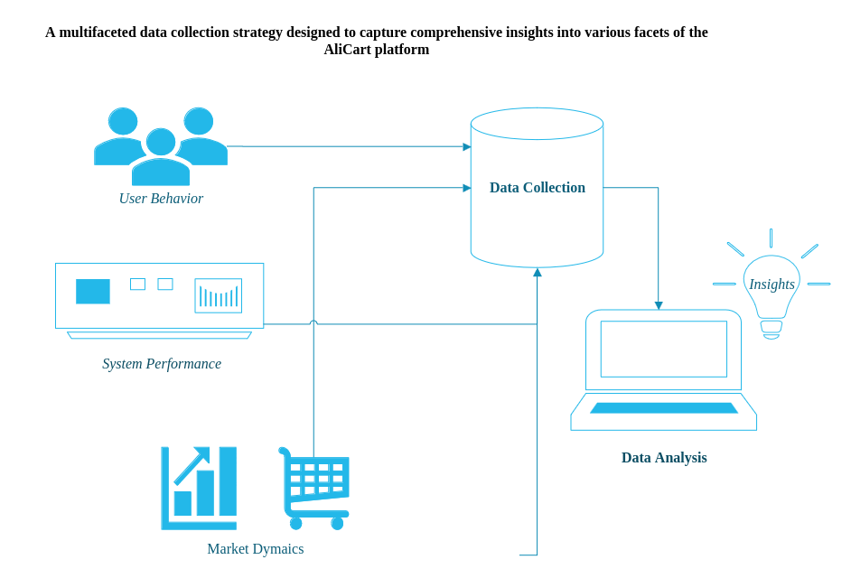In parallel, qualitative data is obtained through surveys, interviews, and focus groups with key stakeholders, including vendors, consumers, and platform developers. These qualitative methods enable in-depth exploration of user experiences, preferences, and challenges, as well as stakeholder perspectives on the platform's usability, functionality, and value proposition. By capturing the voices and insights of diverse stakeholders, qualitative data enriches the research process, providing nuanced context and meaning to quantitative findings.

Ethical considerations are paramount throughout the data collection process, ensuring participant confidentiality, voluntary participation, and informed consent. Measures are implemented to safeguard participant privacy and confidentiality, including anonymization of data, secure data storage protocols, and adherence to ethical guidelines and regulations governing human subjects research. By prioritizing ethical principles and practices, the research upholds the integrity and trustworthiness of the study outcomes.

### Data Analyses

Data analysis constitutes a critical phase of the research process, involving the systematic examination and interpretation of collected data to derive meaningful insights and conclusions. The analysis encompasses both quantitative and qualitative techniques, each tailored to the specific nature and characteristics of the data sources and research questions.

Quantitative data analysis involves statistical methods such as regression analysis, correlation analysis, and hypothesis testing to identify patterns, relationships, and trends in the data. Descriptive statistics are used to summarize key metrics and indicators of platform performance, user engagement, and market dynamics. Inferential statistics are employed to test hypotheses, evaluate relationships between variables, and assess the significance of findings. By applying rigorous statistical techniques, quantitative data analysis yields robust empirical evidence to support research conclusions and recommendations.

In tandem with quantitative analysis, qualitative data is subjected to thematic analysis to identify recurring themes, patterns, and insights emerging from the data. Thematic analysis involves systematic coding, categorization, and interpretation of qualitative data to uncover underlying meanings, perspectives, and experiences expressed by participants. Through an iterative process of data immersion, coding, and theme development, qualitative analysis generates rich, contextualized insights into user behavior, preferences, and challenges, complementing quantitative findings and enriching the overall research narrative.

### Validity and Reliability

Ensuring the validity and reliability of research findings is paramount to maintaining the integrity and credibility of the study. To enhance internal validity, measures are implemented to control for potential confounding variables, minimize biases, and establish causal relationships between variables. Pilot testing is conducted to refine survey instruments, interview protocols, and data collection procedures, ensuring the clarity, relevance, and appropriateness of research instruments.

Furthermore, triangulation of data sources and methods is employed to enhance the validity and reliability of research findings. Triangulation involves corroborating findings from multiple data sources or using multiple methods to investigate the same phenomenon, thereby increasing confidence in the accuracy and robustness of the findings. By triangulating quantitative and qualitative data, as well as utilizing multiple data collection methods, the research mitigates the risk of methodological biases and enhances the credibility of research conclusions.

### Limitations

Despite efforts to ensure rigor and validity, the study is subject to several limitations that may impact the interpretation and generalizability of the findings. Limitations include constraints on sample size, potential biases in participant recruitment and data collection methods, and the contextual specificity of the study setting. The use of convenience sampling techniques may introduce sampling biases and limit the representativeness of the sample, thereby affecting the external validity of the findings.

Moreover, the study's reliance on self-reported data from participants may be susceptible to social desirability biases, response biases, and recall biases, potentially influencing the accuracy and reliability of the data. Additionally, the study's focus on a specific geographic region and market segment may limit the generalizability of the findings to other contexts or populations. Despite these limitations, efforts are made to acknowledge and address potential biases and constraints, thereby enhancing transparency and rigor in the research process.

#### Project Milestone

*Table 5 Project Milestones and Deadlines*

|  |  |  |
| --- | --- | --- |
| *Week Number* | *Work to be done* | *mm/dd/yy* |
| Week 1: Planning and Research | * Define Goals and Objectives * Market Research | 09/25/2023 – 10/01/2023 |
| Week 2:  UX Design | * Complete UX Design: * Finalize website UX design. * Develop wireframes and mockups. * User Testing: * Collect feedback from users or stakeholders. * Apply design adjustments as needed. | 10/02/2023 - 10/08/2023 |
| Week 2 - 10: Front End Development | * Frontend Development | 10/09/2023-11/19/2023 |
| Week 10 - 25: Back End Development | * Backend Development | 11/20/2023 – 02/28/2024 |
| Week 26 - 28: Testing and Optimization | * Perform comprehensive website testing, covering functionality, security, and performance. * Address and resolve any identified bugs or issues. * Enhance website speed and overall performance. * Apply SEO best practices to improve product listings. | 02/29/2024 - 03/15/2024 |
| week 29 - 34: Content Creation | * Create and upload product listings, images, and descriptions. * Write engaging and informative content. | 03/16/2024 - 03/29/2024 |
| Week 34 - 38: PreLaunch Marketing | * Develop a marketing plan for the website's launch. * Prepare social media accounts and email marketing campaigns. | 03/30/2024 - 04/13/2024 |
| Week 38 - 40: Launch | * Website Launch * Launch the ecommerce website. * Monitor for any postlaunch issues and address them promptly. | 04/14/2023 - 04/27/2024 |
| Week 40 and Beyond: PostLaunch Activities | * Marketing and Promotion | 04/28/2024 - 05/15/2024 |

#### Gantt Chart

*Figure 1 Gantt Chart for Project Milestones and Deadlines*

## CHAPTER V: SYSTEM DESIGN AND USER GUIDE

### **System Design**

The Platform: AliCart is an eCommerce Django web application with an easy-to-use interface designed for numerous user roles. Three user categories are intended to be supported by the e-commerce: Superuser, who is essentially the platform's developer and owner, with admin dashboards for suppliers and a straightforward user interface for customers:

The system is made up of several pages and parts that offer the features required for efficient and comfortable buying and selling.

#### **Login Page**

Users must enter their credentials on the login page, which serves as the system's entrance point, in accordance with their responsibilities and permissions. There are two different ways to log in: vendor and customer and superuser.

*Figure 2 Login Page*

#### **Dashboard**

The platform supports three types of dashboards. The admin dashboard is the first place where a vendor or consumer enters their basic information, such as name, bio, phone number, and address. This information is then automatically used when making a purchase, saving the user from having to enter it again and again. Besides, if a customer creates an account and places their order in this dashboard, they will be able to check all their purchases along with their status and all details.

*Figure 3 Dashboard*

Vendors will have access to a second dashboard where they may alter or add products to their existing inventory, as well as view statistics related to their store page on the website.

The third dashboard is for the superuser, website owner, or anyone in control of the website after lunch. They can conduct all the tasks in the shop, including adding new users and vendors and modifying the previously listed products, among other things.

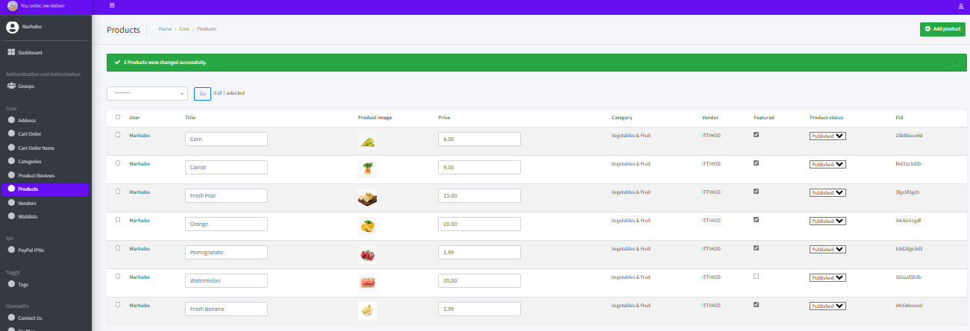

### **User Guide**

For those who are used to online purchasing, the website's navigation is fairly simple and comparable to that of prominent websites. All of the various categories are listed in a sidebar on the left, making it simple to browse and locate what you're looking for. The navigation menu also provides all the necessary items to make the purchasing process easier. Additionally, there is a contact page for immediate support and problem-solving.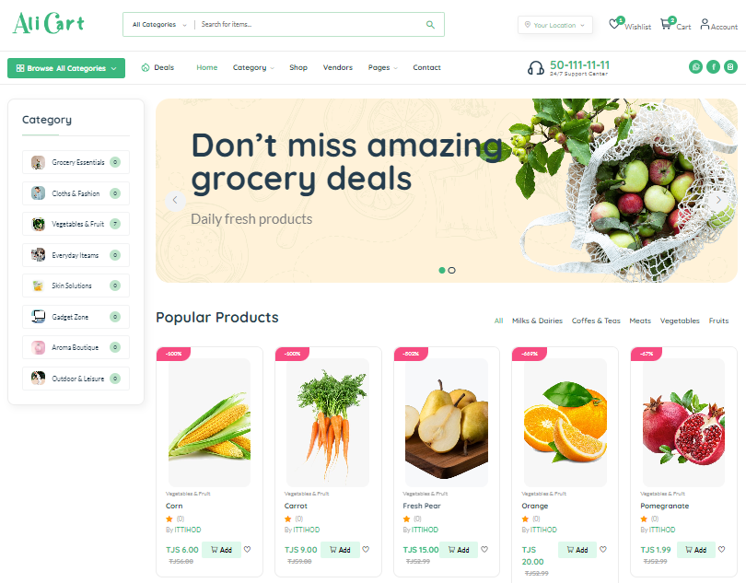

### **Django Models and Database Design**

As it has been mentioned before the website is mainly developed using python and Django and below you can find the Entity Relational Diagram and relational schema:

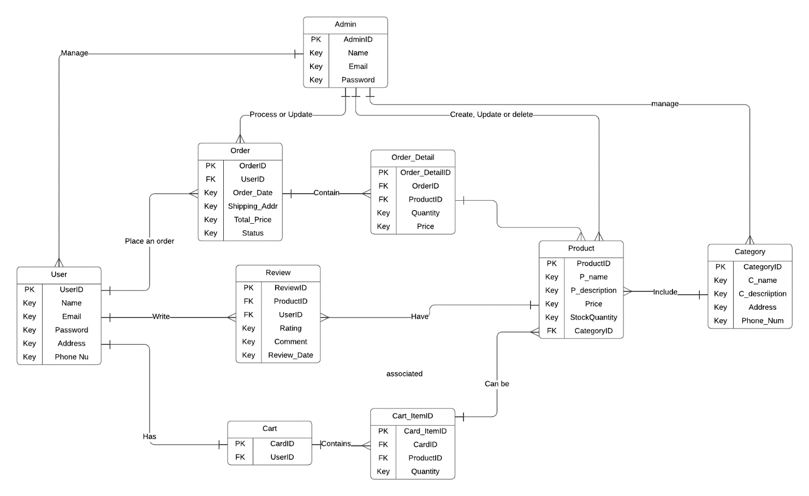

*Figure 4 Entity Relational Diagram of the platform*

*Figure 4 Relational Diagram of the platform*

### **Django Models and Database Design**

#### **Frontend Frameworks and Technologies**

* djangockeditor5: A rich text editor that can be embedded in web pages.
* djangocrispyforms: Helps to manage Django forms and can render forms in a frontend framework like Bootstrap.
* djangojazzmin: Customizes the Django admin interface, enhancing the frontend user experience.
* djangojqueryjs: Provides jQuery, a fast, small, and featurerich JavaScript library.
* djangojsasset: Aids in including JavaScript assets in Django templates.
* djangostaticfontawesome: Provides FontAwesome icons that can be used in the frontend.
* djangoformsetjsimproved: JavaScript utilities for managing Django formsets dynamically in the browser.
* djangotinymce: A webbased JavaScript HTML WYSIWYG text editor.
* crispybootstrap5: Facilitates the use of Bootstrap 5 with Django forms to render frontend layouts

#### **Backend Frameworks and Technologies**

* Django: The primary backend web application framework.
* djangorestframework: A toolkit for building Web APIs with Django.
* djangorestframeworksimplejwt: Integrates JSON Web Tokens (JWT) with Django REST Framework for authentication.
* djoser: Django library that adds endpoints for registration, authentication, and user actions.
* channels: Extends Django to handle asynchronous protocols like WebSockets.
* daphne: ASGI server for Django, serving HTTP, HTTP2, and WebSocket traffic.
* gunicorn: A WSGI HTTP server for serving Python applications.
* djangorestauth: Provides easy RESTful API endpoints for authentication.
* djangoenviron: Utilizes environment variables for Django settings.

## CHAPTER VI: RESULTS AND DISCUSSION

### Results of user testing and Comments

The website was recently launched and is currently undergoing testing. Our staff members and partners from our physical stores are conducting the tests. This week, we are trialing the website exclusively with our regular customers before considering a broader rollout. So far, the website has been praised for its simplicity, user-friendly interface, easy navigation, and readily available services. As of now, all customers who have used and tested the website are satisfied and are increasingly adopting it for regular use.

### Testing Outcomes and Steps Taken

Initially, we implemented a payment option requiring users to enter their card details, which raised some security concerns since online purchasing isn't yet commonplace, and trust in such transactions is still developing. In response, I adapted the payment system to one more familiar to our customers—payment through QR code scans, uploading checks, and receiving confirmation messages. Although this method may seem complex, it aligns with the current norms of my community. Once users become more accustomed to the website, I plan to update the payment method.

### Contributions and Achievements of the E-Commerce AliCart

The launch of AliCart is set to revolutionize the e-commerce landscape in Badakhshan, offering easy online access to a wide range of products and creating a ripple effect of benefits. The platform is expected to save customers time and travel expenses, empower local vendors by widening their market reach, and invigorate the market through heightened competition. Additionally, it is poised to generate jobs, bolster the local economy, and build consumer trust in online shopping. The platform also has the potential to lower the carbon footprint of shopping and promote regional crafts, with the added advantage of gathering consumer data to further refine the shopping experience. Should it succeed, Its model could be a template for similar positive change in other regions.

## CHAPTER VII: CONCLUSION AND FUTURE WORK

### Limitation of the present study and the suggestions for further investigation or enhancement of future research

Because online markets in the Pamir region of Badakhshan are still in their infancy, the current study of e-commerce platforms in Tajikistan has some limitations. The dearth of active e-commerce platforms just one was introduced in Pamir and isn't up and running makes thorough study difficult. The depth of analysis is further hampered by the paucity of previous research publications on the Tajik market, particularly in isolated regions like Pamir. Therefore, in order to get around these obstacles and improve knowledge of Tajikistan's potential for e-commerce, future study should concentrate on in-depth investigation and analysis.

### Future Recommendations

Based on the study findings, several recommendations are proposed for future research endeavors aimed at extending and refining the research findings. Future research should explore alternative methodologies, such as longitudinal studies or experimental designs, to further validate the effectiveness and sustainability of tailored ecommerce solutions in diverse contexts. Efforts should also be made to expand the sample size and diversify participant demographics to enhance the external validity and generalizability of the findings.

Furthermore, ongoing research is warranted to assess the long-term scalability, adaptability, and sustainability of the AliCart platform in response to evolving market dynamics, technological innovations, and user preferences. Longitudinal studies tracking the platform's adoption, usage, and impact over time would provide valuable insights into its long-term efficacy and value proposition. Additionally, comparative studies benchmarking the AliCart platform against existing solutions would elucidate its competitive advantages and unique value proposition in the ecommerce landscape.

By adhering to a comprehensive and systematic methodology that integrates diverse research methods and approaches, the study generates valuable insights into the development, implementation, and impact of the AliCart ecommerce platform. This methodology chapter serves as a guide for conducting the study, outlining the research design, data collection methods, analysis techniques, and evaluation strategies employed to achieve the project objectives effectively. Through rigorous adherence to ethical principles, methodological rigor, and transparency, the study upholds the integrity and credibility of the research outcomes.

## REFERENCES

[1] Akhrorova, A. D. (2022). Trends in the digitalization of the economy of Tajikistan and its banking sector. *Digital Technologies in the Contemporary Economy: Collective Monograph*.

https://ejournal.unsrat.ac.id/index.php/emba/article/view/11874

[2] Gairatovich, S. B. (2018). To Analyze Behaviour of Young Consumers Towards the Use of Digital Technology in Tajikistan. *Universidade do Porto*.

https://iopscience.iop.org/article/10.1088/1757-899X/940/1/012071/meta

[3] Ida Ayu Debora, I. A. (2016). Analysis the factors influence consumer buying decision on online shopping clothing for consumer in Manado. *Sam Ratulangi University*.

https://openurl.ebsco.com/EPDB%3Agcd%3A8%3A1120056/detailv2?sid=ebsco%3Aplink%3Ascholar&id=ebsco%3Agcd%3A161236146&crl=c

[4] Jamal, F., & Kapoor, V. (2022). Smart Clothing and Wearables: A Review of Fashion Technology. *IUP Journal of Brand Management, 19*(4), 50.

https://www.proquest.com/openview/ea2282e4e1b33b2375bbba9c058db55a/1?pq-origsite=gscholar&cbl=18750&diss=y

[5] Mukimova, N., & Berdieva, N. (2022). Prerequisites for the development and implementation of digital innovations in Tajikistan. In Ž. Simanavičienė (Ed.), *Digital Technologies in the Contemporary Economy: Collective Monograph*.

https://www.scitepress.org/Papers/2022/113537/113537.pdf

[6] Reena, M., Hardeep, S., Arpit, B., Svetlana, B., & Nelli, K. (2020). Comparative analysis of the consequences of purchasing models transformation within the global digitalization of the economy. *IOP Conference Series: Materials Science and Engineering, 940*(1), 012071.

https://cris.mruni.eu/cris/entities/publication/8a3bb629-eed3-45de-9343-dad018350153

[7] Temurbekova, S., & Sulaimonov, A. (2022). The Role of Information Technologies in the Digital Economy of the Republic of Tajikistan. *Tajik State Financial and Economic University*.

https://cris.mruni.eu/cris/entities/publication/e144d0e9-8843-41dd-9189-5cb39c5840f3

[8] Tulyev, M. S. (2022). Some Questions of Digitalization in the Countries of the World and Republic of Tajikistan. *Tajik State University of Commerce*.

https://www.elibrary.ru/item.asp?id=46251507

[9] Amin, Shahid & Kansana, Keshav & Majid, Jenifur. (2016). A Review Paper on ECommerce.

[10]Xiao, Tingting; Ai, Shizhong; and Zhang, Weili, "Policy Recommendations for Promoting the Development of CrossBorder ECommerce between China and Central Asian Countries" (2018). WHICEB 2018 Proceedings. 35. https://aisel.aisnet.org/whiceb2018/35

[11] Kalaskar, Shruti & Dalimkar, Pratiksha & Shegokar, Dhanashree & Ghagare, Sudhir & Khandare, Prof. (2023). Design and Development of Ecommerce Website. International Journal of Advanced Research in Science, Communication and Technology. 4247. 10.48175/IJARSCT9368.

[12] Komilova, M. DIGITAL TRANSFORMATION OF FINANCIAL INFRASTRUCTURE OF TAJIKISTAN.

[13] Қурбонов, М. А., & Исматуллои, Ш. (2020). ANALYSIS OF DEVELOPMENT OF ELECTRONIC COMMERCE DIRECTIONS IN THE REPUBLIC OF TAJIKISTAN. Вестник Бохтарского государственного университета имени Носира Хусрава. Серия гуманитарных и экономических наук, 2(S14), 251255.

[14] [Amazon](https://www.amazon.com/)

[15] [Pamir.shop](https://pamir.shop/)

[16] [EBAY](https://www.ebay.com/)